Specifications
  - Date
Doc Version 1.0

Customer: | Hidrostal
Project: | Support for existing customers
Proalpha version: | 7.1e
Proalpha Installation(s): | DE
Product variant: | │ Proalpha ray  ☒ Proalpha classic  Note: If "Proalpha ray" is enabled, the following is also done Always implemented in the classic client.
GUI language: | German
Author: | Andreas Herr
Created on: | 21.05.2025
Last change on:
Contact Customer: | Sascha Marohn

This document describes a modification or expansion of the standard software in Proalpha in the product variant defined above and has been checked by the customer. The functional design in chapters 2 - 4 is hereby released for technical specification and costing in compliance with the requirements in section "Final Provisions":

......................................................
Date and Signature of Customer

Contents
1. [UPDATE THE TABLE] 3
1.1 [UPDATE THE TABLE] 3
1.2 [UPDATE THE TABLE] 3
1.3 [UPDATE THE TABLE] 3
1.4 [UPDATE THE TABLE] 3
2. [UPDATE THE TABLE] 4
2.1 [UPDATE THE TABLE] 4
2.2 [UPDATE THE TABLE] 4
2.3 [UPDATE THE TABLE] 5
2.4 [UPDATE THE TABLE] 5
3. [UPDATE THE TABLE] 6
3.1 [UPDATE THE TABLE] 6
3.2 [UPDATE THE TABLE] 7
4. [UPDATE THE TABLE] 8
4.1 [UPDATE THE TABLE] 8
4.2 [UPDATE THE TABLE] 8
4.3 [UPDATE THE TABLE] 8
5. [UPDATE THE TABLE] 8
5.1.1 [UPDATE THE TABLE] 8
5.1.2 [UPDATE THE TABLE] 8
5.1.3 [UPDATE THE TABLE] 8
6. [UPDATE THE TABLE] 9
7. [UPDATE THE TABLE] 10
7.1 [UPDATE THE TABLE] 10
7.2 [UPDATE THE TABLE] 10
8. [UPDATE THE TABLE] 11

References
CR dated 09.05.2025.

Summary and Objectives
In order to be able to assess the priorities for the orders to be packed and to bring forward the orders that should have been delivered earlier, the field 1 is to be used. Confirmed date can be used as filter criterion in the shipping monitor filter. In addition, the field is to be displayed in the shipping monitor and sorted by it.

Description of requirements
Make the "1. Confirmed Date" field in the sales order line available as a filter option in the shipping monitor. The field is to be displayed on the monitor and sorted by it.

Requirements Glossary (Terminology)

Term | Explanation
shipping monitor | Monitoring function of sales orders sent before or at the same time as staging.
- | -
Table 1Requirements Glossary

Origin of field "1. Confirmed delivery date"
The quick entry of the sales order features a customization in which the first order is entered. Delivery date has been entered (ExDelivery Date field).
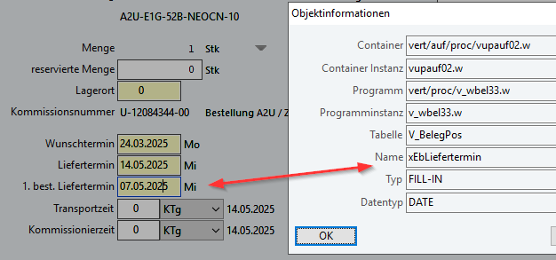
Mapping 1: Origin field "1. beg. Delivery Date"

Filter option in the options filter of the shipping monitor
In the options filter, the field is available as a filter criterion and only the orders that correspond to the filter criterion are displayed in the shipping monitor overview (figure see section 2.3).
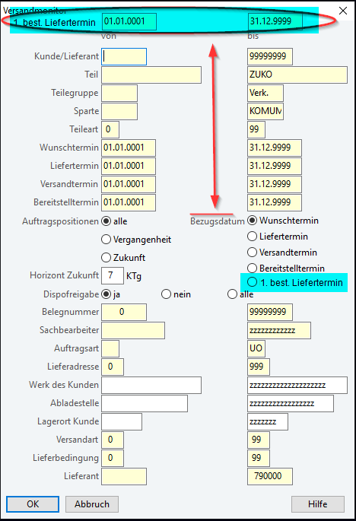
Mapping 2: (shipping monitor options filter)

In the shipping monitor, a new column is inserted in which the date values from the field are displayed.
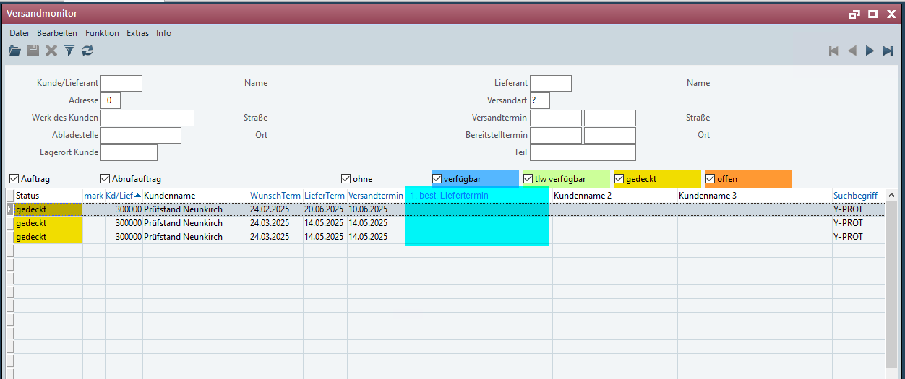
Mapping 3Overview: Shipping Monitor

The column is indexed so that it can be sorted by date value.

Differentiation
The customization refers to the tables, fields and programs mentioned.
This specification sheet does not automatically add functional extensions to the adjacent modules of the Proalpha environment, such as the DMS, Analyzer, reports, and forms. The Proalpha help is not automatically expanded.
Changes to adjacent modules/programs must be described and defined in the specifications sheet. It also includes changes to the graphical user interface. If Ray is not explicitly mentioned here, the present modification refers to the Classic Proalpha client.

Test cases
The specified test cases map the customization described here and are the basis for the acceptance of the software.

Filter criterion in the options filter
Pt | Explanation | Expected result | Test data
 | An open sales order has different dates (requested, delivery and first order) for a line. Date). It is processed after the first order. Date Filtered | The order is displayed accordingly.
 | Test result (incl. screenshots)
 | An open sales order has different dates (requested, delivery and first order) for a line. Date). A date range is entered that is OUTSIDE the first order. Date is. | The order is NOT displayed.
 | Test result (incl. screenshots)

Sorting
Pt | Explanation | Expected result | Test data
 | Prerequisite: successful passing of test case 1 & 2:  There are several order lines with different dates in the "1. Order Date" available. Now, you sort by the date in ascending or descending order by clicking on the column heading. | The orders are displayed in ascending or descending order according to the date values.
 | Test result (incl. screenshots)

Technical Requirements
-

Organizational Requirements
-

Notes about the go-live
-

These specifications form the basis for customer-specific expansions of the standard software Proalpha®.
The customer-specific extensions only cover the area defined in this specification sheet. Functionality beyond this scope is not provided.
Unless explicitly agreed otherwise, the customer-specific extensions are only created in German: no programs, program parts or data are translated into other languages. This also applies to the languages supported by Proalpha® in the standard version.
The customer-specific extensions are thoroughly tested before they are delivered. However, for technical reasons, it is not possible to perform the test under the same conditions and with the same data as the customer will use. It is therefore recommended to carefully check the functions in the real system environment after their delivery.
The Customer is aware that variances in the display details or handling of the functions defined in this specification sheet may be required for the transfer of the functions defined in this specification sheet to new versions of Proalpha®. This specification sheet also remains valid in this case, provided that there is a maintenance agreement for the customer-specific extensions defined in this specification sheet and no changes to the functionality have to be agreed on.
This specification sheet documents the customer-specific extensions. No other documentation beyond the specifications contained in this specification sheet is to be provided. Questions about customer-specific extensions are received and forwarded by the hotline.
By signing on page 1, you confirm:
- that the specification sheet is accepted in this version and becomes part of the contract,
- that this specification sheet defines the functional scope of the software to be created and that there are no side agreements regarding the functionality,
- that a technical specification is created for the specification sheet, which is then invoiced separately if the quote for the implementation of the specification sheet is not ordered in the context of the quote validity.

Table of Figures
[UPDATE THE TABLE] 4
[UPDATE THE TABLE] 4
[UPDATE THE TABLE] 5

Table of tables
[UPDATE THE TABLE] 3

Doc. -  Version | Date | Specialist | Initiator | Chapter | Explanation
1.0 | 21.05.2025 | Andreas Herr | Sascha Marohn | All | Initial new entry

